Terry Walters – Power Plus
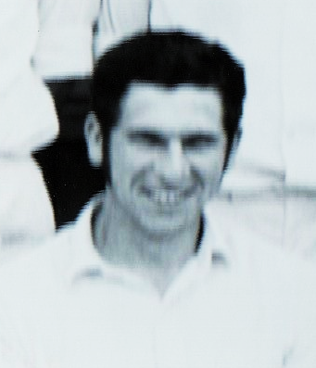
Terry the younger brother of celebrated Test star Doug Walters, joined the Parramatta Club from hometown Dungog in 1966/67.
He possessed a strong robust frame and was an exceedingly powerful and gifted right-handed batsman and a lively part-time medium paced bowler.
He commenced his sojourn into Sydney Premier Cricket in 1966/67 in Parramatta’s ‘C’ Grade Municipal and Shires team under the stewardship of club doyen Bill Anderson. But after two games Terry promptly revealed his all-round talents – scoring 54 runs @ 54.00 and destroying Waverley at Birchgrove Oval No.1 by claiming 7/29 and 5/40.
These efforts saw him elevated into Fourth grade for the remainder of the season where he contributed 222 runs @ 17.07, highlighted by a forceful 76* against North Sydney which provided a first real glimpse of the ferocity he could generate with a cricket bat in his hands.
In the 1967/68 season Terry continued to raise his personal level of performance and lodge a claim for higher grade selection. Veteran skipper Stan Teale stated in the annual report that – “Terry is a naturally gifted cricketer; he topped both the batting and bowling averages and always fielded brilliantly. Terry, if he applies himself and gives a little more concentration to his whole game, must surely make the First Eleven very soon.”
With the bat he struck 322 runs @ 53.67 (H.S. – 56 v. Gordon, 62* v. St. George, 55* v. Bankstown, 46* v. Mosman) and with the ball he snared 13 wickets @ 9.50 (B.B. – 6/21 v. Gordon, 4/34 v. Sydney University) and he was also given a taste of Third grade.
The 1968/69 season marked a seminal moment in Terry Walters career with Parramatta (Cumberland), still operating as an all-rounder he started proceedings in Third grade and finished with the last three matches in First grade [Parramatta District Cricket Club First grade Player Number: 382].
His batting during the season reflected his free-flowing stroke play with attack foremost on his mind and in all grades, he cracked up 394 runs @ 20.74 (1sts – 65, 2nds – 141, 3rds – 188), highlights: 54 v. St. George [3rds], 53 v. Petersham [2nds] and although his medium-pacers were less used in the higher grades he still claimed 14 wickets @21.78 (B.B. – 5/31 v. Randwick [3rds]) for the season.
It all came together for Terry in the 1969/70 season with a bang. Initially selected in Second grade and with a few seasons experience of premier cricket under his belt he stepped onto centre stage and bludgeoned 283 runs @ 56.50 in the first four matches – 93 v. Sydney, 55 v. Petersham and swashbuckling 135 v. Balmain (maiden century for Parramatta) in which he shared 178 runs 2nd wicket partnership with stubborn opener Ken Hall.
This brilliant burst of form pitchforked him into First grade where batting at No.3 he continued to carve out runs in his block-busting fashion, his season’s tally totalled 589 runs @ 42.07 – an epic 125* v. Northern District was the standout effort, but he enjoyed a run sequence of 57, 60, 39, 125, 69, 91 and 57. He formed a formidable ‘top 3’ for the Cumbos that compiled 1,933 runs and helped steer the team to the First grade Minor Premiership.
Walters’ 1969/70 total aggregate of 872 (1sts – 589, 2nds – 283) set a record for the most runs in a season for the Parramatta (Cumberland) club – surpassed in 2016/17 by current First grade captain Nick Bertus.
Post the 1969/70 season the dynamic batsman got wanderlust played intermittently for Parramatta up to 1971/72, mixing his tenure with the club amongst a range mid-season Country Captain – Coach appointments in regional NSW.
During this period of scattered appearances Terry’s quality was displayed with batting gems such as 100 v. Balmain (1970/71); 89* v. Balmain, 72 v. Sydney University (1971/72). Highlight of the season was witnessing the stroke-play of the Walters brothers whilst they forged 156 run 4th wicket partnership against Sydney University.
Back from the Bush, Terry produced a fine swansong season with the two-blues in 1974/75, exhibiting all the power and muscle his batting was known for on his way to fashioning a healthy 521 runs @ 27.42, headed by a spectacular 152 v. Northern District at Old Kings Oval.
In total he scored he compiled 2,907 runs @ 32.26 (H.S. – 152) in all grades in NSW Premier Cricket for the Parramatta District Cricket Club, snared 51 wickets @ 17.00 (B.B. – 7/29), and accepted 45 catches. He made four centuries for the club.
Terry represented NSW Colts in 1971.
He would have been made for today’s T20 cricket, his raw hitting power would have been a real crowd-pleaser. I’ve been around the Parramatta club since the mid-1960s and the only Parra batsmen I’ve see to rival Terry in strength and power were Wally Clifton, Benny Abbott and Luke Dempsey.
A classic example of his destructive capability occurred in match against Waverley in 1969/70, in a 2.6 over assault on Waverley’s NSW left-arm wrist spinner David Hourn, Walters put 47 runs with Tom Wood, Terry scored 44 of those runs.
Unfortunately, he died tragically in a motor vehicle accident on the NSW North Coast in 2008.
T. Walters – Parramatta District Cricket Club Statistics
Grade | Runs | H.S. | Average | Catches | Wickets | Average
M & S -Shires | 98 | 44 | 49.00 | 3 | 12 | 9.75
4th Grade | 544 | 76* | 28.63 | 12 | 15 | 14.07
3rd Grade | 234 | 54 | 15.60 | 1 | 18 | 18.44
2nd Grade | 424 | 135 | 38.55 | 6 | 1 | 58.00
1st Grade | 1,607 | 152 | 34.93 | 23 | 5 | 29.80
Total Grade | 2,907 | 152 | 31.26 | 45 | 51 | 17.00
P-Gray Shield | 468 | 63 | 33.43 | 8 | 15 | 19.13
Total Club | 3,375 | 152 | 30.96 | 53 | 66 | 17.48
New South Wales Colts v. Queensland Colts

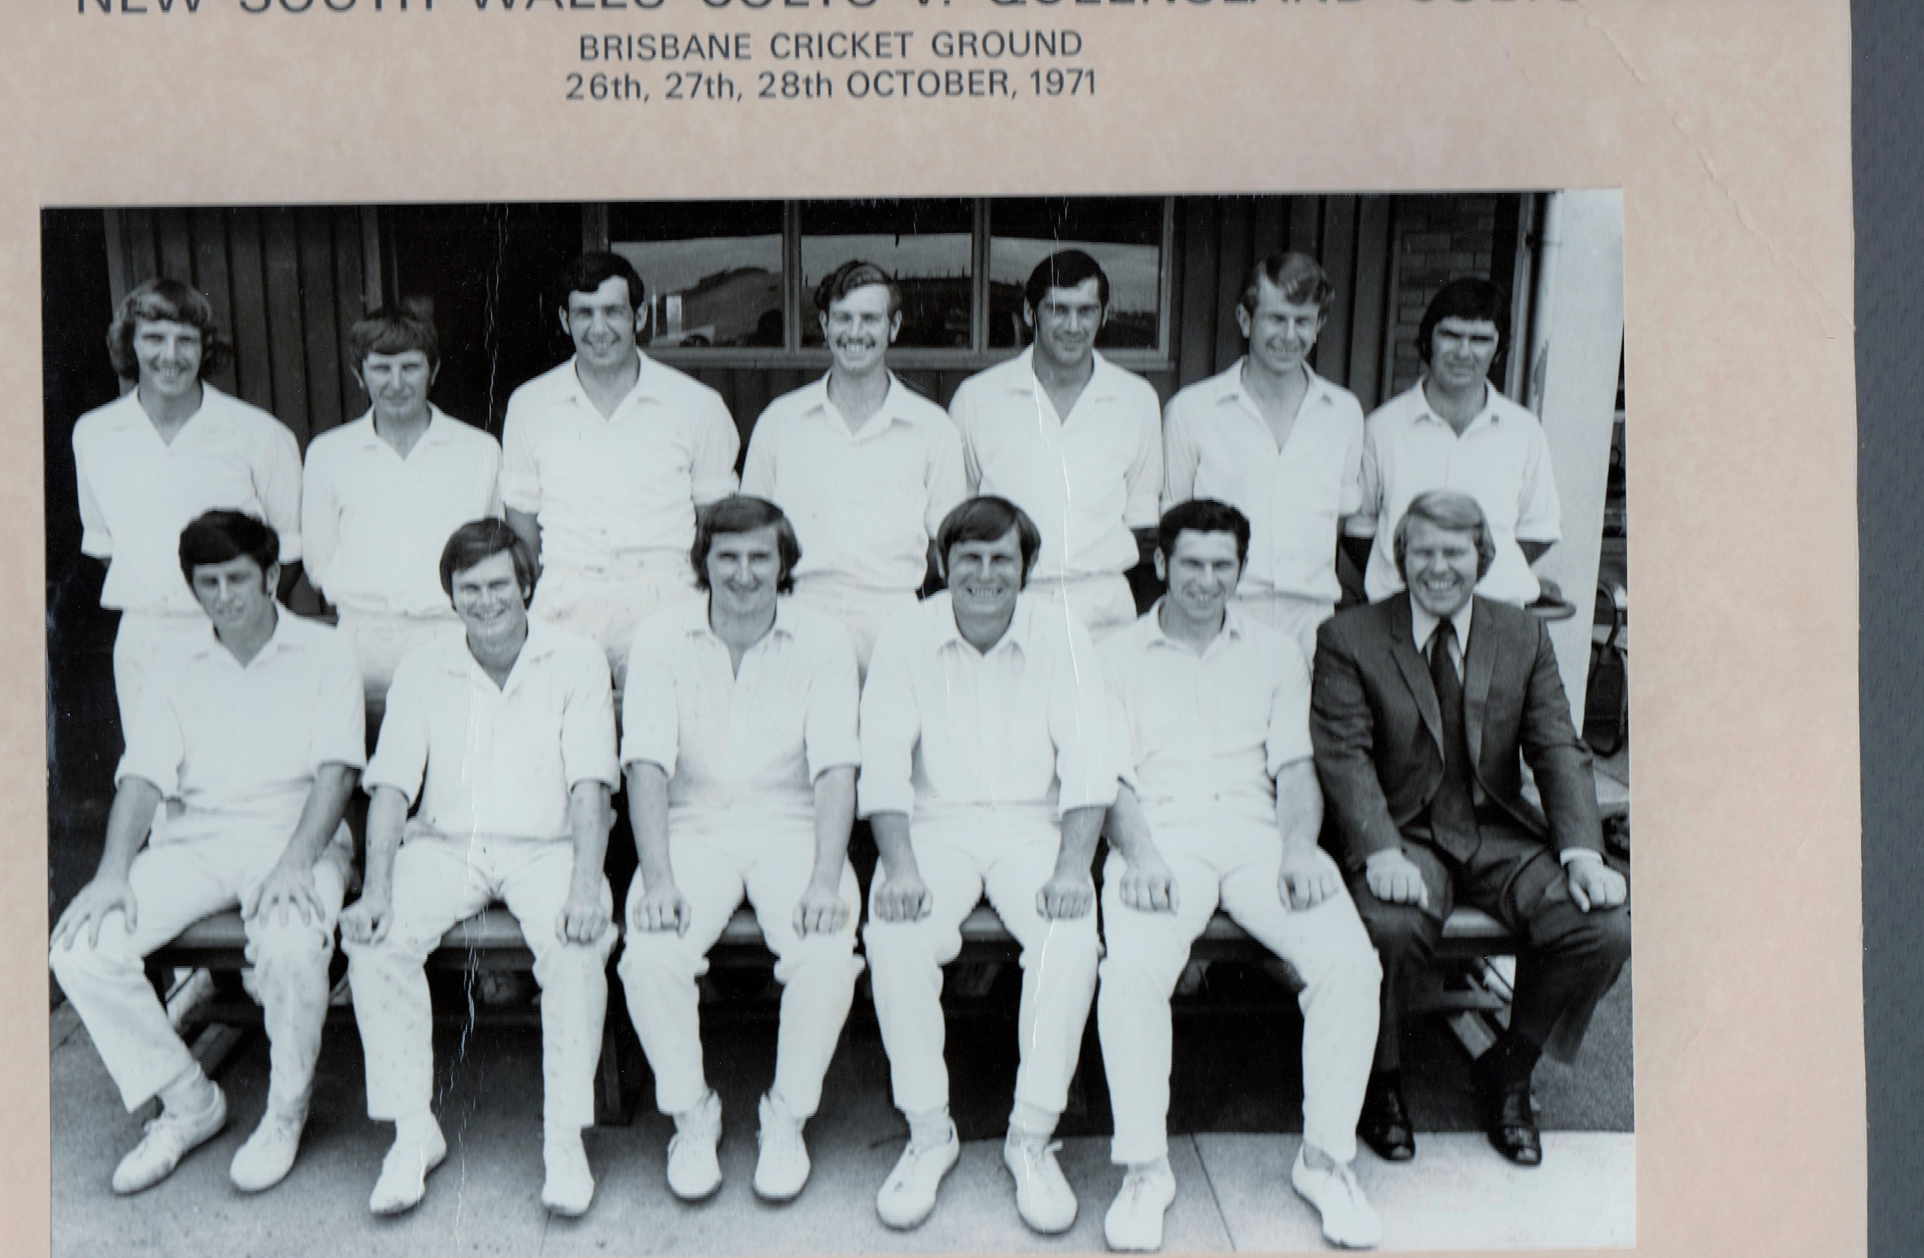
Back Row: Robert Thomas, Tom Wood, Colin Fletcher, David Chardon, Barry Thebridge, Marshall Rosen, David Hourn.
Front Row: David Falkenmire, Garry Gilmore, Allan Anderson (capt), Terry Walters, Dick Guy (Mgr).
[By Tom Wood – Parramatta District Cricket Club Historian]

