Kye Thornley – Edge of Pace
Kye Thornley is a tall, strapping young right-arm fast bowler who possesses that most-sought-after attribute – raw pace. He is a novice young cricketer with a bright future beckoning. In the brief timeframe since his NSW Premier Cricket debut in 2021/22 he has already been a member of a First Grade Belvidere Cup winning team.

Kye’s ascent to date has been quite remarkable. He only made fleeting appearances in Parramatta’s A.W. Green Shield team over two seasons – 2019/20 and 2020/21 – for the sum of 7 runs @ 7.00 and 2 wickets @ 22.67 – figures that provide little indication as to how well he was deemed to rise in the next few seasons.
He entered the Premier Cricket ranks fulltime in 2021/22 via Fifth grade in modest fashion scoring 130 runs @ 26.00 (H.S. – 42* v. Gordon) and collected 11 wickets @ 20.82 (B.B. – 2/15 v. Penrith, 2/27 v. Easts). Team captain Liam Gillies described Kye’s efforts as “being able to bowl thunderbolts, though at times inconsistent, has a lot of promise, with his raw pace and aggression a key point. If he works on his skills over the off season he will be pushing for higher grades’.
Realising Thornley’s great potential the Parramatta selectors were keen to build on his experience and promoted him to Fourth grade at the start of the 2002/23 season. It proved to be a masterstroke; he enjoyed a breakthrough season snapping up 22 wickets @ just 14.36.
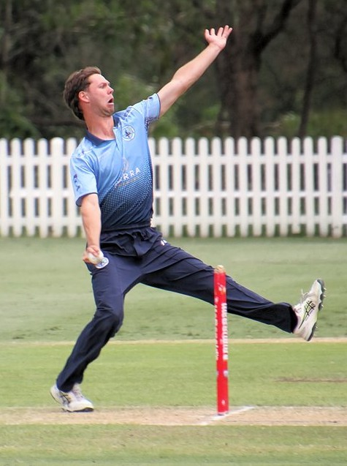
As the season progressed Kye increased his pace and tightened his control and often had opposing batsmen on the retreat with performances such as 4/34 v. Fairfield and 4/21 v. UNSW, but he ‘gained another leg’ and became lethal during the final series – he rattled Gordon in the Semi-Final capturing 4/19 and then grabbed his first ‘5for’ for the club when grabbed 5/61 v. Manly to be awarded ‘Player of the Match’ in a losing Grand-Final team.
These performances revealed an ability that earmarked him as a definite higher grade prospect, a fast bowler with the ‘sharp edge of speed and combative streak’ that could boost the potency of the Second and First grade bowling attacks.
On the back of his previous season’s Fourth grade exploits Kye was elevated direct to Second grade in 2023/24. He jumped at his chance and flourished and bowled with gusto – pace and intimidation were his trademarks in securing 20 wickets @ 17.00 (B.B – 5/57 v. Eastern Suburbs). This impressive form earned him promotion to First grade – becoming Parramatta District First Grade Player Number: 623.
He handled the lift in grade with aplomb, turning in some quick, wholehearted efforts that added a sharper edge to the attack, and formed a promising partnership with fellow pacemen Michael Sullivan and Isaac Earl. His hard labour yielded him 12 wickets @ 21.25 (B.B. – 4/34 v. Sydney University). Overall, his season’s wicket tally read 32 wickets @ 18.53 (1sts – 12, 2nds – 20).
The best was yet to come, 2024/25 became a hallmark year for the Parramatta club capturing the coveted Club Championship and the First, Third and Fifth grade premierships. Kye performed strongly procuring 33 wickets @ 16.94 (B.B. – 5/29 v. Blacktown, 4/22 v. St. George, 3/22 v. Northen District, 3/13 v. Sydney, 3/22 v. Blacktown, 4/62 v. Gordon, 3/38 v. Hawkesbury) in all formats and he was a key member of the First grade bowling attack on its march to the Belvidere Cup.
After a very encouraging start to the 2025/26, in which he bowled with pace and vigour to capture 13 wickets @ 13.08 (B.B. – 3/15 v. Mosman), he suffered the dread of all pace bowlers, a back injury, that ended his season – until then Kye looked ‘every inch’ a rising fast bowling force.
Hopefully he’ll be back sending his rockets down next season and adding substantially to his 115 wickets @ 17.76 (all grades) collected to date for Parramatta.
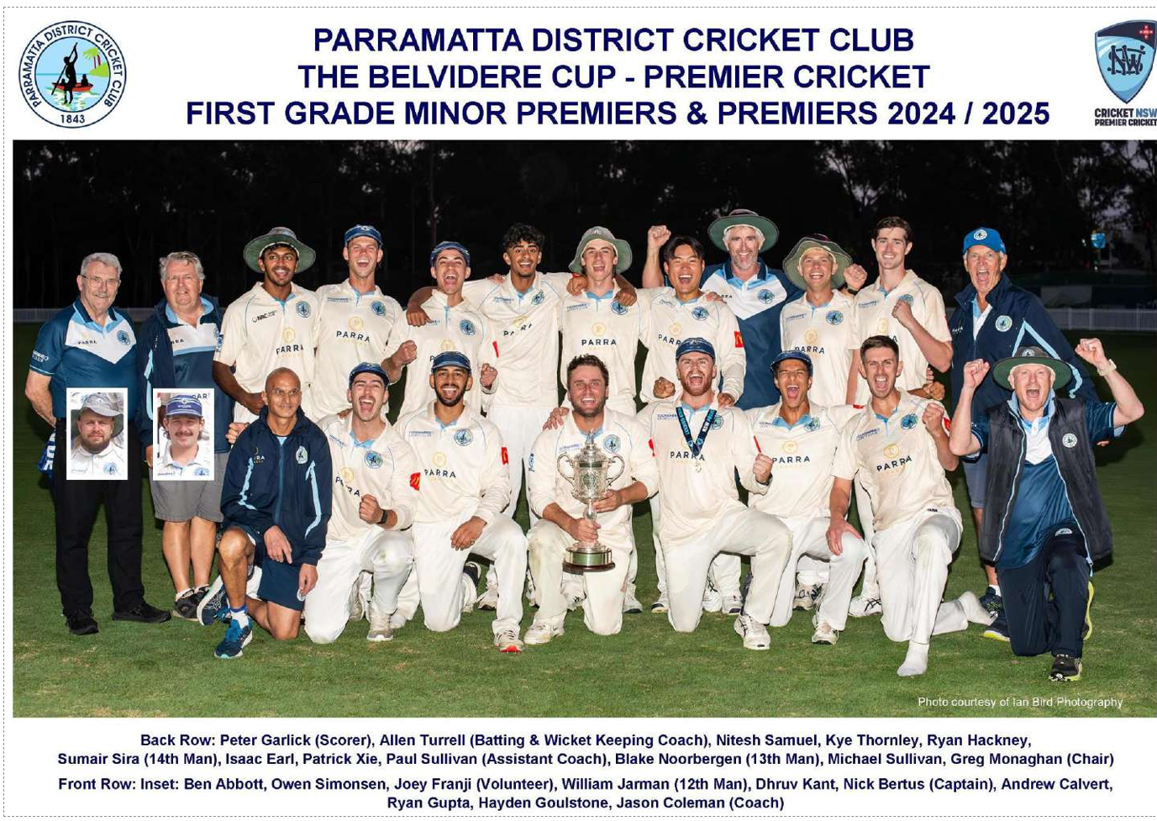
[By Tom Wood – Parramatta District Cricket Club Historian]

