John R. ‘Jack’ O’Donoughue – Mr Consistency
Jack O’Donoghue was one of those pugnacious cricketers who simply loved grade cricket. A loyal clubman to his core, a right-hander who opened the batting with determination, grit and a propensity to ‘give the ball a whack’, whether playing in First or Second grade, regardless of the pitch conditions.
A Popular and enthusiastic bloke, he represented Central Cumberland for almost a quarter of a century, from 1929/30 to 1951/52.
He served the club continuously as a player and was especially valuable during World War II, when he became the cornerstone of the Second grade side during a difficult period.
Like for all Grade clubs the 1940s was a turbulent era for Cumberland (Parramatta) firstly the drain on players, club finances and resources during the dark days of W.W.II made it difficult for the club to stay afloat, and then secondly when society was trying to recover from the aftermath of the War in the last portion of the decade.
Jack O’Donoughue proved to be a ‘tower of strength’ for the club during these troubling times – apart from the odd recall to First grade – he managed the fortunes of the club’s Second grade team, captaining them in his thoughtful and tactically aware manner.
The feisty right-handed opener was a consistent and productive run-maker throughout this time, despite playing all his cricket on uncovered wickets that were often subjected to the vulgarities of mother nature. Throughout the 1940s he led his team from the front and was usually the team’s leading run-maker, his effectiveness is illustrated by the following highlights:
- 1938/39 – Second grade 445 runs @ 30.93 (H.S. – 100 v. N.D, 94 v. Mosman, 59 v. Wests).
- 1940/41 – he produced his best season in First grade (452 runs @ 30.10 – 93 v. Marrickville, 94 v. Petersham), plus 70 @ 70.00 in Second grade – Total 522 runs.
- 1942/43 – Second grade – 414 runs @ 19.75 (H.S. – 100). He also captained First grade in a few matches making 96 runs (Total – 510 runs).
- 1944/45 – proved to be his highest Second grade run tally – 520 @ 26.00 (H.S. – 105 v. Paddington).
- 1945/46 – Second grade – 480 runs @ 25.20 (H.S. – 71 v. Petersham, 61 v. Marrickville, 68 v. Gordon, 55 v. Mosman).
- 1946/47 – Second grade – 441 runs @ 20.04 (H.S. – 56 v. Petersham).
- 1947/48 – Second grade – 485 runs @ 25.22 (H.S. – 83 v. Mosman).
- 1948/49 – Second grade – 442 runs @ 27.62 (H.S. – 100 v. Mosman, 74 v. Waverley).
- 1949/50 – Second grade – 329 runs @ 27.41 (H.S. – 61 v. Wests).
Jack stands in 8th place on the list of Parramatta’s heaviest scoring batsmen (all grades), making a massive 8,265 runs @ 20.16 in all grades (including 5 centuries – 1st x 1, 2nd x 4).
In his debut season (1929/30) with the club he made a rapid rise, going from the Shires team through each grade to finish in First grade.
Over the bulk of his time at Central Cumberland, he alternated between First and Second grade he competed for an opener’s spot at various times against the likes of NSW players Len Leabeater, Jack Fitzpatrick, Ernie Crossan and club run-scoring icon Bert Alderson.
In First grade Jack was a handy contributor with 1,893 runs @ 17.05 (H.S. 111) – his best season’s return was in 1940/41 when he garnered 452 runs @ 30.10. But the highlight of his 1st grade career was undoubtedly being a member of the club’s 1932/33 1st grade premiership winning team, and he had the honour of being that great side’s sole centurion when he made a bright 111 against Sydney University.
But it was Second grade that provided the best theatre for O’Donoughue to display his full ability. He churned out runs season after season, leading the way with the bat providing stability to the team that in the troubled 1940s (as highlighted above).
His aggregate for career runs in Second grade still stands as the unchallenged club record for that grade – 5,733 runs @ 21.40 (H.S. 105), and on six separate occasions he won the batting double of aggregate and averages. Jack’s best season’s output was in 1944/45 when he made 520 runs @ 26.00 (H.S. 105).
Perhaps his greatest contribution to the club’s cause was during the W.W II years and the period of re-establishment soon afterwards was his long reign as Second grade captain (1942 – 1951). As a ‘skipper’ Jack was highly regarded as an inspirational and positive leader full of the love of cricket and the challenges the game imposed – the club’s annual reports speak of the respect his players held for him.
Jack’s son Rodney later also became a well-known local cricket identity firstly as a well performed opener in the Parramatta District Junior Cricket Association’s A grade competition for the Merrylands Club and later as the long-term President of that association.
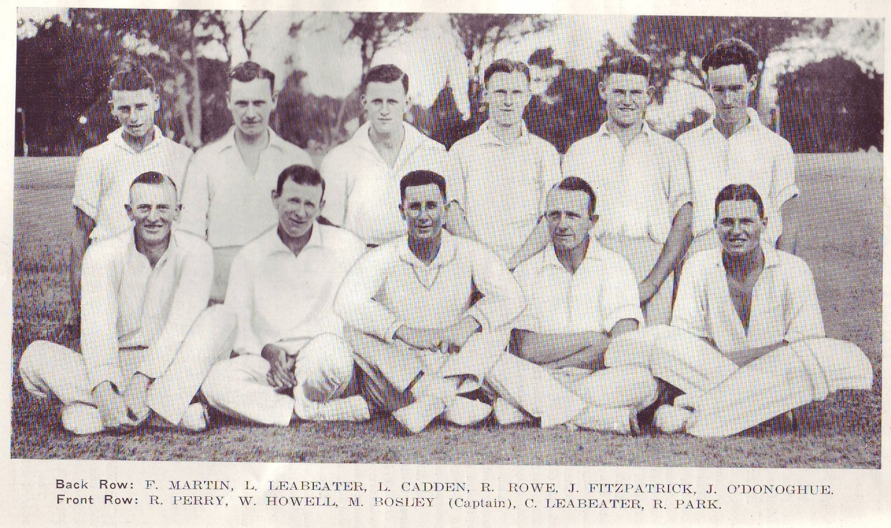
Central Cumberland – 1932/33 NSWCA First Grade Premiers

[By Tom Wood – Parramatta District Cricket Club Historian]

