Vishek ‘Vishi’ Chawla – A Passionate Leg-spinner

In 2023/24 Vishi arrived unheralded from the Wenty Leagues Cricket Club to try his fortunes in the NSW Premier Cricket competition with the Parramatta District Cricket Club.
This engaging, enthusiastic cricketer quickly made an impression at Parramatta for his love of the game and his passion for his craft of leg-spin bowling, and the way he has attacked his bowling challenges with spirit and determination.
In his brief period with the club to date Vishi has already ‘made his mark’, by being a key member of the 2024/25 Premiership winning Third grade bowling attack, winning a spot in the 2025/26 First grade Semi-Final team and being on the cusp of the ‘100 wicket’ milestone for P.D.C.C.
He is a bowler who is growing season by season as he gains added experience of Premier Cricket and possesses the skill to become a most valuable player with Parramatta for many seasons to come.
Vishi bowls with good variety, changing his pace and flight cleverly and is adapt at bowling long, probing and economical spells. Compared to his bowling his batting ability has shown to be rather modest.
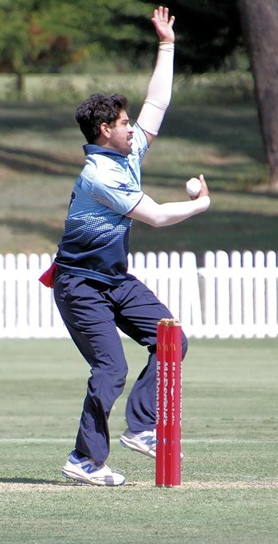
His career with Parramatta kicked off in 2023/24 with a brief stint in Fourth grade but by season’s end he was firmly placed in the Third grade team that reached the Qualifying Finals. He captured a solid 16 wickets @ 19.88 (B.B. – 3/32) and his economy rate of 2.49 was impressive for a leg-spinner. In all grades he collected a respectable first season haul of 22 wickets @ 19.32.
The 2024/25 season further enhanced Vishi’s standing, he played valuable role in helping the Third grade team, skippered by Matt Giumelli, capture the Mitchell Cup as premiership winners and he also experienced a mid-season taste of Second grade before returning to Third grade to assist in the team’s charge to finals.
Throughout the season he bowled splendidly to top the wicket-takers with 29 wickets @ 12.10 (B.B. – 5/47 v. North Sydney [SF], 3/39 v. Gordon, 4/18 v. Sydney University.
His bowling was amazingly frugal for wrist-spinner – 1.85 economy rate – and this enabled his captain to use Vishi to bowl prolonged spells that tied up opposing batting lineups. The best illustration of this talent was his 5/47 v. North Sydney in the Semi-Final which came off a mammoth 28 overs.
The 2025/26 season saw Vishi reach new levels, after performing very steadily in Second grade capturing 25 wickets @ 23.84 (B.B. – 5/36 v. Mosman, 3/23 v. ND, 4/36 v. Sutherland, 4/59 v. Hawkesbury) he was promoted to First grade [Parramatta First grade Player Number: 632] to play in the Qualifying - Final v. Randwick-Petersham and Semi-Final v. Manly.
Given his chance he grabbed it with both hands. In the Qualifying-Final he looked ‘every inch a First grader’ and bowled with great control to snare 3/51 (18.3 overs). With his debut behind him the little spinner bowled beautifully in Manly’s long occupation of the batting crease in the Semi-Final, producing the outstanding figures of 2/38 off a marathon 30.5 overs – his victims NSW players Ollie Davies and Charles Stobbo.
The Parramatta Club hold great hopes that Vishek Chawla will firmly establish himself as a key cog in the First grade team’s bowling attack in the upcoming 2026/27.
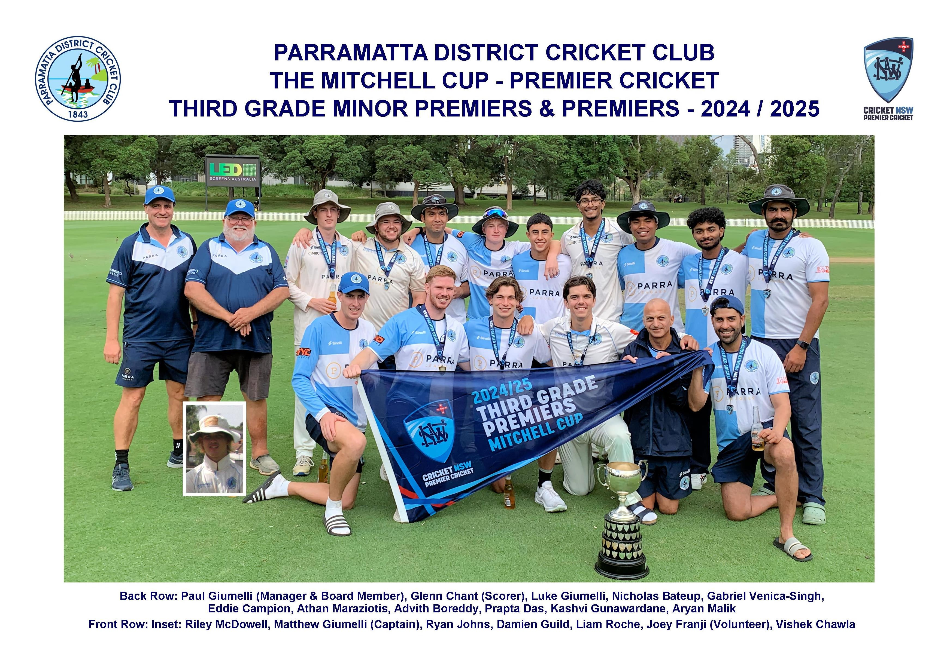
V. Chawla – Parramatta District Cricket Club – Statistics
Grade | Runs | H.S. | Average | Catches | Wickets | Averages | B.B.
4th Grade | 7 | 7* | - | - | 6 | 17.83 | 2/24
3rd Grade | 47 | 17 | 11.75 | 9 | 45 | 14.87 | 5/47
2nd Grade | 7 | 7 | 1.16 | 2 | 35 | 20.87 | 5/36
1st Grade | 0 | 0* | - | - | 5 | 17.80 | 3/51
Total | 61 | 17 | 6.10 | 11 | 91 | 17.52 | 5/36

[By – Tom Wood Parramatta District Cricket Club Historian]

